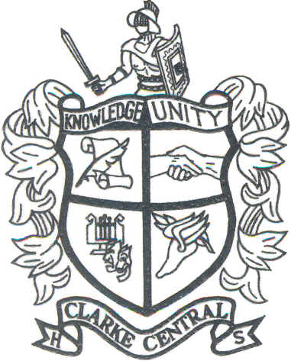
Clarke Central High School
350 South Milledge Avenue
Athens, Georgia 30605
(706) 357-5200
Fax (706) 357-5269
www.clarke.k12.ga.us/cen/
MR. REGINALD THOMAS
ASSISTANT PRINCIPAL

DR. SHEILA DUNHAM
ASSISTANT PRINCIPAL

MS. MARIE YURAN
PRINCIPAL

To Whom It May Concern:

I enthusiastically recommend that Matthew Green be selected as a Community Assistant at Savannah State University. I have known Matthew for several years and I taught him in AP Macroeconomics when he was a senior in high school. Matthew is a remarkable young man and his pleasant personality and leadership capabilities are well suited for this position.

Matthew was an excellent student when he was in high school (he was an All-A Honor Student) and he was highly respected by the faculty and his peers. He was very active in a number of activities including football, wrestling, and track & field. When not studying or competing, Matthew spent a lot of his spare time working with younger children as a volunteer at Clarke Middle School, and Whit Davis and Fowler Drive elementary schools. Since entering college he has continued his commitment to bettering his community as a member of the NAACP and serving as the SGA Freshman Class Vice-President.

In my opinion, Matthew is an excellent candidate for any position of leadership at Savannah State University, and the Community Assistant position is, I am certain, the first of many steps he will take in the direction of becoming a mover and shaker in the student community. His demonstrated success in the classroom and in competitive sports and his commitment to his community assures me that you will be making a great choice in hiring him. Please do not hesitate to contact me if you have any questions regarding his qualifications.

Sincerely,

Mr. Stephen W. Hinson, EdS.
Clarke Central High School
Athens, GA 30605
(706) 357-5200 ext. 17452
hinsons@clarke.k12.ga.us
SCHOOL OF CHAMPIONS

